**Discussion**

Generic problem

A universal problem that I have noticed is locker systems. As our technology advances locker systems aren’t focused on. They are a functioning system that do what they need to do however they could easily be improved upon. In the majority of business’ and educational grounds locker systems are present. Within these campus’ the locker units are generally basic, they operate on a lock and key system. This basic concept is fully functioning however it is becoming old fashioned. The concept of a lock and key is old; holidays homes can now function with cards or wrist bands; safes can use biometric security. This shows that people are trying to get rid of keys. This can be used in lockers, they generally use keys however I believe that they could be functioning without these and use ID cards or a similar device.



Description of problem

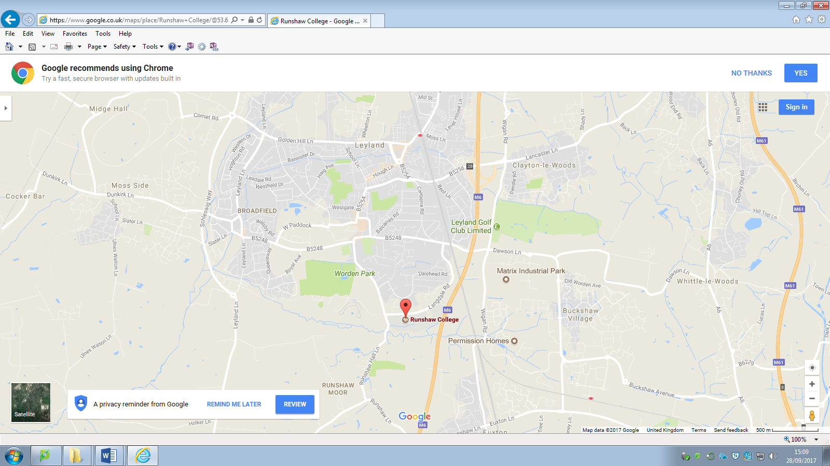The system that is going to be improved is the lockers system at Runshaw college. The college provides a basic locker system that allows people to store their personal possessions securely on campus. Runshaw is a college located on Langdale Road Leyland, it provides A – level courses and equivalent Btec qualifications. It is host to several thousand students ranging from 16 – 19.

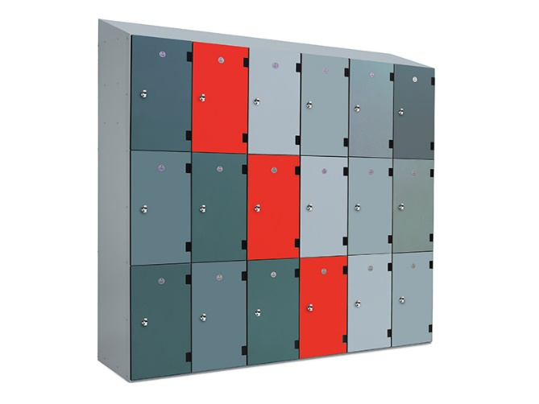 Runshaw college was established in 1974 and since then it has expanded to have an adult college campus in Euxton; this provides degree level lessons and with no doubt will also provide lockers on the campus for the students. In these 40 years, I can confidently say that more of those years were spent with lockers then without.

Lockers are a feature that are going to be in place in almost every educational ground and even most business’. The company provides a lock and key to whomever wishes to own a locker, after they have given in an initial deposit. Runshaw will also store the details of who owns each locker and where the lockers are. It is the duty of the college to ensure that the lockers are secure and each locker is maintained to a useable standard for each person that is using one.

The college runs lessons from 9 o’clock in the morning till 3.40 in the afternoon. With timetables as they it is possible that people can be accessing lockers for these 6 hours hence the current system is able to functionally perform for this duration and then with the other hours in the day fixes and adjustments can be made. For students, they can use their lockers during this timeframe with small extensions either end. They are encouraged to vacate the premises as soon as possible after these hours.

Due to the college performing these lessons and be public it means that the tax payer is the person funding the college furthermore funding the locker system. Being a government funding organisation means it doesn’t fall into the normal company categories (chain franchise or family) as no individual person owns the organisation.

Problem area

The problem with the current system is that it is slow and unused. These to problems link together as the fact that it is slow means that people fear from using it.

Currently staff members will input the student’s data into an electronic database. This brings about problems as it means that there is a chance for human error. A staff member could accidently or purposely input a student’s name or ID wrong causing confusion on the system. They could also input it right however into the wrong part of the database also causing problems on the system.

Lockers are a common feature amongst most company’s worldwide. In this specific case, they take up a lot of space within the college grounds and this means that they should be of high standard and provide a more than adequate performance.

[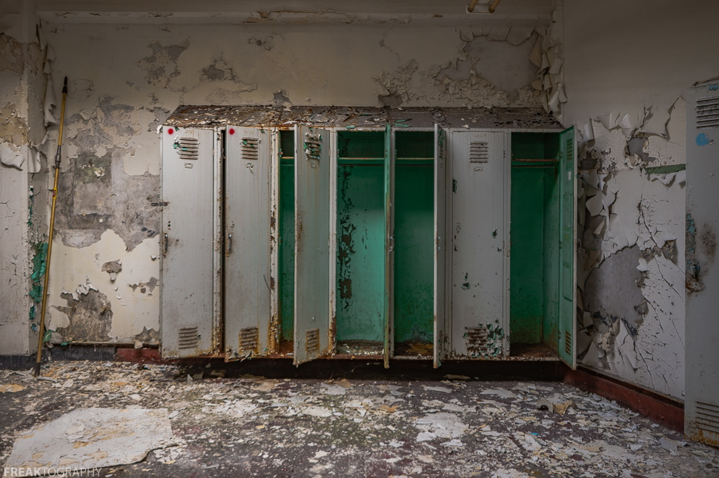](https://www.google.co.uk/url?sa=i&rct=j&q=&esrc=s&source=images&cd=&cad=rja&uact=8&ved=0ahUKEwjZz46TiMjWAhWEbhQKHa8yDnQQjRwIBw&url=https://hiveminer.com/Tags/lockerroom,lockers&psig=AFQjCNHCcqtXrwuHwFFY_qnfD1oZ20T1xg&ust=1506694370298455) The lockers on campus do work. However, it is inefficient. This means that there are no plans to expand the system at all. Simply a new system is being designed to replace the old one, but fulfil the same purpose to the same scale.

As the college continues to run and the electronic generation continue to flood into the college more and more people are going to fear away from using any manual system. The lockers being manual are not keeping up with the ever-changing technical world. This means that in the inevitable future these out of date lockers will become derelict due to their lack of use; hence a change in the system is needed to ensure that they are kept functioning.

Stakeholders

On the current system, there are only two stakeholders, being: -

* Staff
* Students

Both these groups only use the system when they are on campus. For students, this will be the opening hours previously stated in the description and for teachers this will be slightly longer. There are few members of staff and students that may need to be present on both campus’ under the name of Runshaw but most people will be based at one particular campus.

Aims for planned solution

Runshaw must personally remove the old locker system as the new one is not an expansion but an improvement. They must also educate admins and students in how to operate the lockers and how staff can monitor the database.

For staff, there must be a simplistic database which easily accessed and understandable. This means that the upkeep of the system will be easy and ensure that the quality of the physical and electronic properties is maintained to a more than adequate standard. Staffing members there must be a feature that allows them to open whichever locker they desire as to ensure that pupils can’t abuse their access to these lockers to store their own personal inappropriate possessions.

Students must be provided with a secure locker meaning they can comfortably store their items and quickly retrieve them when desired. A GUI must be displayed to the students ensuring that it is simple. Being simple makes it understandable hopefully this will cause there to be no delays in accessing the system, in turn this should also reduce the time spent on the lockers; one of the main problems with the original system.

There a few outputs that will be provided by the new system. The planned outputs are only the opening of the locker and messages displaying what is currently happening with the system whether it be that lockers are in use or that the system is turned off.

Limitations of planned solutions

There are some limitations of the new system design. The main problem is money, due to the system being incorporated with a physical front end a large cost is involved. It may be impossible to test out the real system with entire locker units. Even without this part of the project the code behind the machine, the back end, will still be tested and thoroughly developed. To ensure that the idea is still

***** FINISH *******

Consideration of Feedback[1]

After presenting the idea to fellow designers I was provided with multiple ideas that may be implemented into the final system. The general feedback was that it was a useful design idea however it may be hard to produce, limited by funding to the college. I was given contributions to my project via suggestions to what I could potentially add to the project. A Runshaw pay service is used for food at college and this could be potentially added to the locker system to ensure that fair access is given to each student and the college does gain from this scheme. A useful bit of information that was given was that the college does already have a QR code system that is linked to students. This QR system makes the login quicker and means that less has to be made for the college.

*****Add more ******

1. 